**Mindoro State University**

**Calapan City Campus**

**College of Computer Studies**

**BUSINESS**

**PLAN**

**Technopreneurship**

**By**



**De Guzman, Nino Bahia, Joyce Ann Ronda, John Edward**

**Presented to**

**WILFRED V. PINE**

**Subject Instructor**

**April 2024**

**DEEPBLUE DIVE EMPORIUM**

**Poblacion, Puerto Galera, Oriental Mindoro**

**Tel. No. 30204**

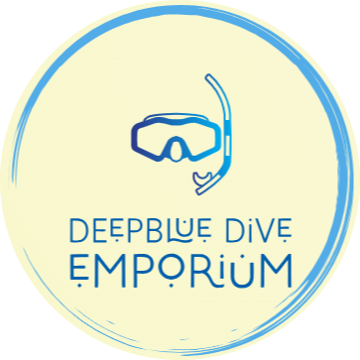

**John Edward Ronda**

**Company Owner**

**CP No. 09530356973**

**Calangatan, San Teodoro, Oriental Mindoro**

**Nino De guzman**

**Partner**

**CP No. 09110842178**

**Panikian, Naujan, Oriental Mindoro**

**Joyce Ann Bahia**

**Partner**

**CP No. 09108742667**

**Aurora, Naujan, Oriental Mindoro**

**Plan prepared April 2024 by**

**John Edward Ronda, Shop Owner**

**TABLE OF CONTENTS**

**TITLE i**

**Cover Page ii**

**Table of Contents iii**

**Statement of Purpose iv**

**Part I. THE BUSINESS 1**

Legal Structure 1

Description of the Business 1

Products / Service 1-2

Location 2

Management 3

Personnel 3

Methods of Record Keeping 3

Insurance 3

Security 4

**Part II. MARKETING**

Target Market 5

Competition 5

Methods of Distribution 6

Advertising 6

Pricing 7

Product Design 7

Timing of Market Entry 8

Location 9

Industry Trends 10

**Part III. FINANCIAL DOCUMENTS**

Summary of Financial Needs 12

Sources and Uses of Funds Statements 13

Cash Flow Statement (Budget) 13

Three-Year Income Projection 14

**SUPPORTING DOCUMENTS**

Appendix A – Facebook Business 15

Appendix B – PowerPoint Presentation 16

Appendix C – Curriculum Vitae / Resume’ 17

**STATEMENT OF PURPOSE**

At DeepBlue Dive Emporium, our mission is to be the premier destination for diving enthusiasts, providing exceptional quality dive gear, expert guidance, and memorable experiences. We believe that diving is not just a hobby but a way of life, connecting individuals with the wonders of the underwater world. Our purpose is to inspire and equip divers of all levels, from beginners to seasoned professionals, with the tools and knowledge they need to explore the depths safely and responsibly. Through our commitment to excellence, innovation, and sustainability, we aim to foster a community of passionate divers who share our love for the ocean and its inhabitants. By offering a curated selection of top-notch products, personalized services, and educational resources, we strive to enhance every diver's journey and make their underwater adventures truly unforgettable. At DeepBlue Dive Emporium, we don't just sell gear – we cultivate experiences, foster connections, and empower individuals to dive deeper, dream bigger, and discover the magic beneath the waves.

The diving shop is located at Poblacion, Puerto Galera, Oriental Mindoro near the Candava Supermarket. With an initial investment of P200,000 and a loan of P500,000, DeepBlue Dive Emporium will have the money it needs to become a thriving hub for everything related to diving. We'll have top-quality gear, personalized services, and learning materials to make every diver's experience amazing. Our goal is to make diving more exciting and accessible for everyone.

**PART I**

**THE BUSINESS**

**Legal Structure**

A partnership is an agreement between two or more people whose goal is to run a business. While on a partnership form of business the people behind a certain venture will share every aspect of the business especially on the financial and debts likewise with the profits and loses of the business. Being on a partnership, the resources that you could accumulate is limited because the number of owners is also limited to the one you trust the most to handle the business. On that case being on a partnership you could talk about your plans, goals, suggestions and recommendations regarding on your business venture to your partners therefore you could come up to an efficient decision making. On that being said, partnership legal structure is the safest to begin with if you are afraid to start alone. Having someone with the same interest as you, with the same mindset and dedication to improve your business together is an asset to your business.

**Description of the Business**

DeepBlue Dive Emporium is a specialty retail store dedicated to serving diving enthusiasts. Our emporium offers a comprehensive selection of high-quality dive gear, accessories, and educational resources. At DeepBlue Dive Emporium, we provide a curated collection of products tailored to meet the diverse needs of our customers. From essential equipment such as wetsuits, masks, and regulators to specialized accessories including underwater cameras and dive lights, we strive to offer the latest innovations from renowned brands in the diving industry.

**Product**

Our curated product lineup includes a diverse range of dive equipment such as wetsuits, masks, snorkels, fins, regulators, buoyancy control devices (BCDs), dive computers, and underwater cameras, all designed to meet the highest standards of quality and functionality. Additionally, we provide an array of accessories including dive bags, knives, underwater lights, maintenance kits, communication devices, and dive flags, ensuring divers have everything they need for a safe and enjoyable underwater adventure. Furthermore, our educational resources encompass books, manuals, DVDs, online courses, workshops, and seminars, offering valuable insights and training to enhance diving knowledge and skills.

**Service**

DeepBlue Dive Emporium is more than just a retail store; it's a hub for exceptional services that elevate the diving experience for enthusiasts of all levels. Our team of experienced and passionate dive professionals is dedicated to providing personalized services in enhancing safety, knowledge, and enjoyment in the underwater world. Our services include expert gear fitting and consultation to ensure each diver's equipment is tailored for comfort and performance. We also offer equipment maintenance and servicing to prolong the lifespan of dive gear and ensure excellent functionality. Additionally, DeepBlue Dive Emporium hosts regular workshops, training sessions, and informational seminars covering a wide range of topics including dive safety, equipment care, underwater photography, and marine conservation. Whether customers are seeking gear advice, equipment maintenance, or educational opportunities, our commitment to excellence and customer satisfaction ensures that every visit to DeepBlue Dive Emporium is a valuable and enriching experience.

**Location**

DeepBlue Dive Emporium is located at Poblacion, Puerto Galera, close to the Candava Supermarket. Our store is easy to spot with our bright signs, and once you step inside, you'll find a welcoming space filled with all the diving gear you need. Plus, being near the supermarket means you can easily combine your dive shopping with other errands or activities in the area.

**Management**

The management is composed of the three of us which are colleagues in real life. We have the same interest, goals and aspirations that’s why we came up to this idea. This business venture is our dream and we continue to dream for it as it goes bigger and conquers a lot of challenges and happy memories.

**Personnel**

At DeepBlue Dive Emporium, our team is small but dedicated, consisting of the owner and two other members responsible for the day-to-day operations of the business. As we continue to grow, we recognize the need to expand our team with individuals who share our passion for diving and are eager to contribute to the success of our emporium. We are currently seeking to recruit team members to fulfill various roles within our establishment, including dive gear specialists, dive instructors, and retail associates.

**Methods of Record Keeping**

Customers, sales and inventory are very significant for a start-up business owner. DeepBlue Dive Emporium employs an inventory management system to track stock levels, monitor product sales, and facilitate timely reordering of merchandise. This system allows us to categorize inventory, record product quantities, and reconcile inventory counts with sales data, minimizing the risk of stockouts or overstock situations.

**Insurance**

Every business should have insurance to protect businesses from losses due to events that may occur during the normal course of business. This insurance requires for everyone’s beneficial.

**Security**

Our business must be sure the security of all employees and clients. To keep the business safety, we can provide safety precautions or equipment to prevent unauthorized activity, fire, theft prevention and detection and other unexpected incidents.

**PART II**

**MARKETING**

**Target Market**

DeepBlue Dive Emporium is a friendly place for anyone who loves diving! Whether you're new to diving or a pro, we're here to help. Our team is ready to give you advice and find the perfect gear for your adventure, no matter your skill level. We've got everything you need, from beginner basics to the latest high-tech equipment. And if you're looking for excitement, we've got you covered there too! Dive into thrilling wreck sites or explore beautiful coral reefs – we'll help you make memories that will last a lifetime. We're not just about selling gear; we're also part of the local diving community. We host events and support conservation efforts to help keep our oceans healthy for future generations to enjoy. So, whether you're a local or just visiting Puerto Galera, come on in and let us help you make your diving dreams come true. At DeepBlue Dive Emporium, we're all about making diving fun, easy, and unforgettable!

**Competition**

DeepBlue Dive Emporium faces competition from several local diving industry, including Frontier Scuba, Big Apple Dive Resort, and Badladz Dive Resort. While DeepBlue Dive Emporium may share some similarities with its competitors, such as selling dive gear and equipment, it differentiates itself by focusing exclusively on retail operations, providing a wide selection of premium dive gear, accessories, and educational resources. Additionally, DeepBlue Dive Emporium aims to create a welcoming environment for divers of all levels, offering the best service, expert advice, and memorable shopping experiences that set it apart from the competition.

**Methods of Distribution**

DeepBlue Dive Emporium employs different channel distribution strategy to reach customers and fulfill orders effectively. Our distribution methods include our physical retail store. Our physical retail location serves as the primary distribution channel for customers who prefer to browse and purchase dive gear in person. Located in Poblacion, Puerto Galera, our store offers a welcoming and immersive shopping experience, allowing customers to interact with products firsthand, seek expert advice from our knowledgeable staff, and make informed purchasing decisions. In addition to our physical store, DeepBlue Dive Emporium operates an online store to provide to customers who prefer the convenience of shopping from home or anywhere. Our e-commerce platform provides a user-friendly interface for browsing products, placing orders, and accessing detailed product information and customer reviews. Orders placed online can be shipped directly to customers' homes or picked up at our physical store, offering flexibility and convenience for shoppers.

**Advertising**

In preparing our advertising strategy, DeepBlue Dive Emporium will mainly focus on using social media platforms, and other local advertising channels. Firstly, our emphasis will be on social media marketing, making use of platforms such as Facebook and Instagram to engage with our target audience and showcase our products and services. Through regular posts, stories, and interactive content, we aim to build brand awareness and promote customer engagement. Additionally, we'll use flyers to spread the word about DeepBlue Dive Emporium in Puerto Galera. These flyers will be placed in spots where lots of people go, like diving areas, tourist spots, hotels, and local businesses. They'll have catchy designs and clear messages to grab attention and make people curious about what we offer. We'll highlight our awesome dive gear, expert advice, and any special deals or events. Plus, we'll make sure to include our store location, contact details, and website so people can easily find us. By using flyers, we aim to make more people aware of DeepBlue Dive Emporium, attract new customers, and become a familiar part of the local community.

**Pricing**

DeepBlue Dive Emporium uses a pricing strategy that keeps quality high and prices fair, aiming to please a wide range of customers while still making good money. We figure out our prices based on a few things: first, how much it costs us to get the products, including materials, labor, and other expenses. Then, we look at what other dive shops are charging and what people are willing to pay. We also think about the value our products bring, like their quality, brand reputation, and how much customers like them. Sometimes, we might change our prices to match what's happening in the market or to run special deals.

|  |  |
| --- | --- |
| Products | Price (low end – high end) |
| Diving Mask | ₱1,500 - ₱5,000 |
| Snorkel (with valve) | ₱500 - ₱2,000 |
| Wetsuit | ₱3,000 - ₱10,000 |
| Fins | ₱1,500 - ₱5,000 per pair |
| Scuba Diving Regulator | ₱10,000 - ₱30,000 each |
| Dive Computer | ₱5,000 - ₱20,000 each |

**Product Design**



The image above is the logo of our shop. Just like any other business a logo will be the trademark of our shop thus we make sure that this logo of ours will stand out among others. The diving mask and snorkel are universal symbols for diving and snorkeling activities. The minimalist design of these icons makes the logo modern and easy to recognize. For the typography, the name “DEEPBLUE DIVE EMPORIUM” uses capital letters. The font is modern and sleek, with a mix of creativity as it shows the letters that looks like waves. Additionally, we used light blue as it aligns with water and ocean theme. The dark blue color of the text matches the color of the icons, creating a cohesive look.

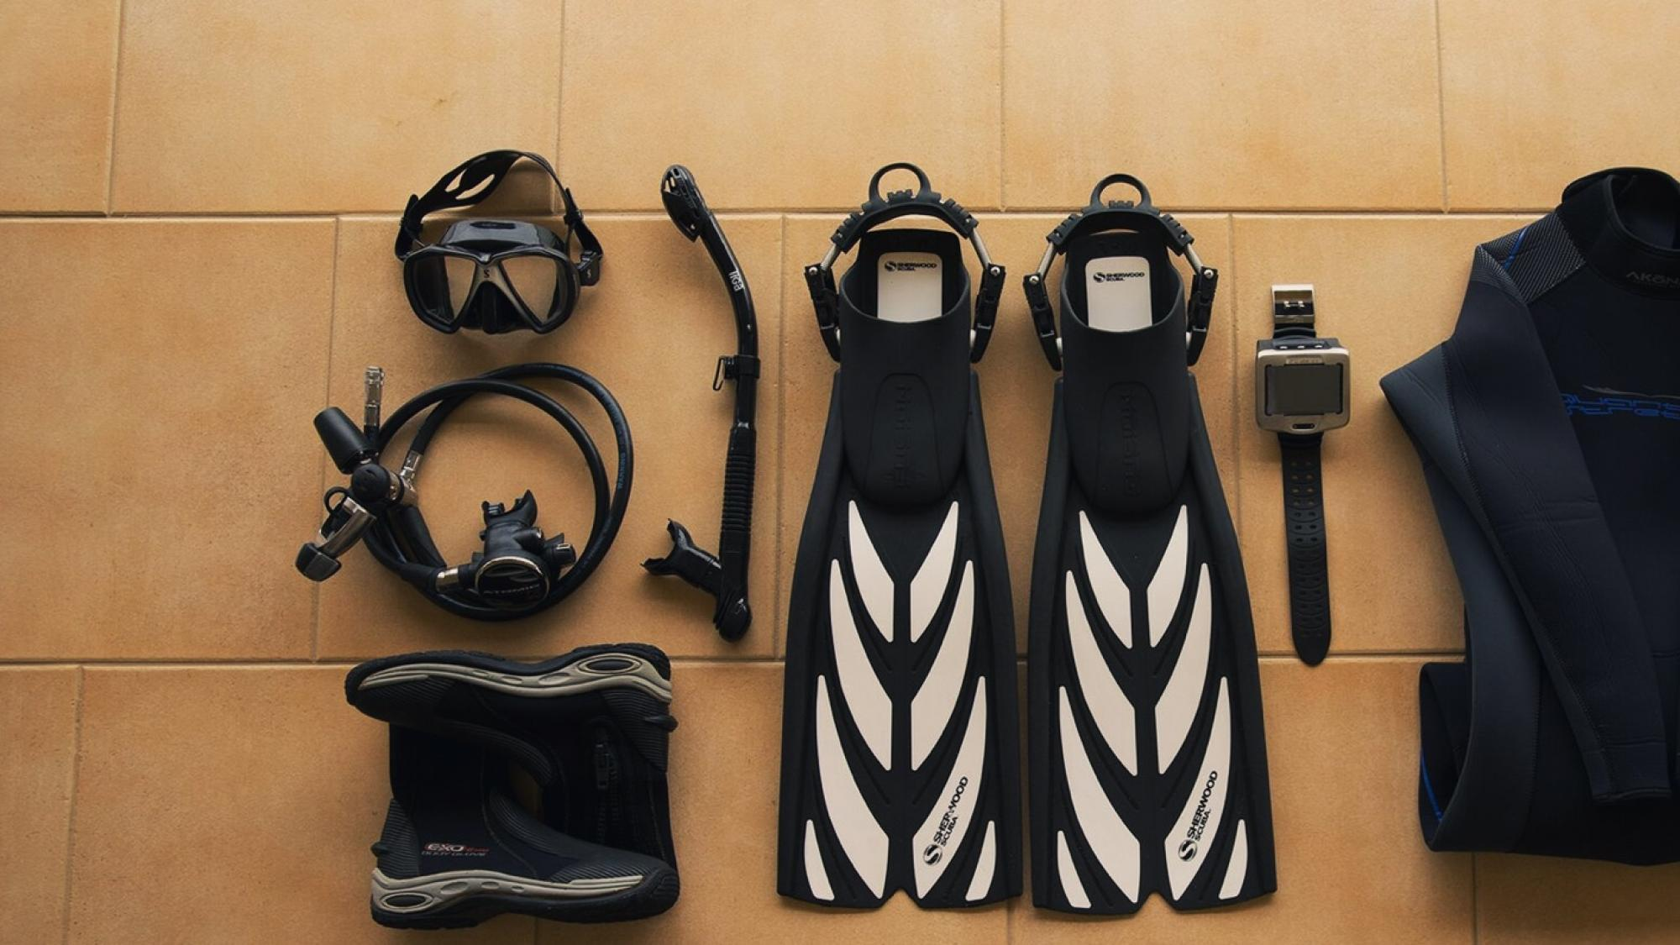

The next image above shows some of the diving gears and equipment of our DeepBlue Dive Emporium.

**Timing of Market Entry**

DeepBlue Dive Emporium carefully chooses when to dive into the market, and it's all about timing. Puerto Galera's diving scene is ever-changing, depending on the seasons. Many divers come to the waters when conditions are perfect– clear visibility, full of marine life, and more. So, we set up shop when diving is at its peak, ensuring we're ready to provide top-notch gear when it's in high demand. But it's not just about the divers; Puerto Galera sees a lot more tourists during specific times, like holidays and school breaks. By launching our business then, we want to connect with more potential customers and stand out in the market. Plus, people tend to spend more time outdoors during certain seasons, making it the perfect time to introduce them to our dive gear. By aligning our launch with these busy seasons, DeepBlue Dive Emporium can create a big impact, attract more customers, and establish ourselves as a go-to destination for diving enthusiasts before our competitors even begin.

**Location**

DeepBlue Dive Emporium will set up shop in Poblacion, Puerto Galera, right next to Candava Supermarket. This location offers some great perks: It's easy to find because lots of people go to Candava Supermarket, whether they're locals or tourists. Plus, Poblacion is in the middle of Puerto Galera, so it's easy to get to from anywhere in town. Since Puerto Galera is a hotspot for tourists, being in Poblacion means we can cater to both tourists and locals alike. And being close to diving spots and resorts makes it super convenient for divers to stop by and grab their gear before hitting the water. Overall, Poblacion is the perfect spot for DeepBlue Dive Emporium to make a splash!

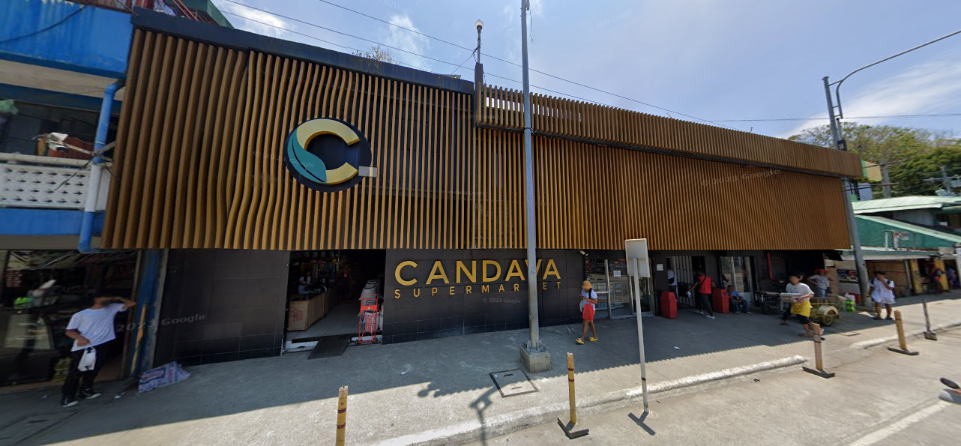

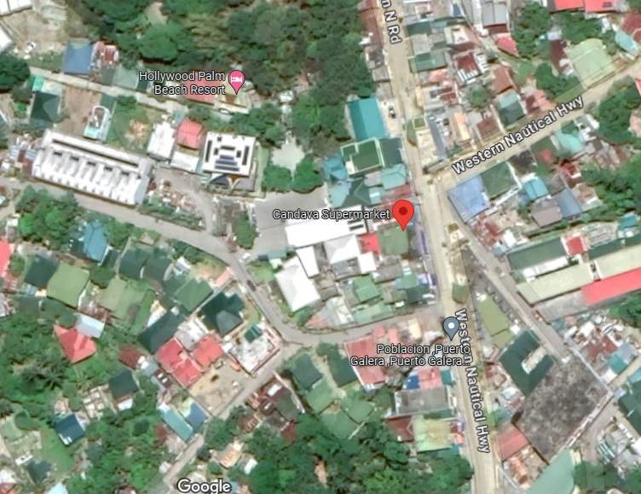

Source: Google Map

**Industry Trends**

DeepBlue Dive Emporium operates in the diving industry, which is influenced by several important trends. Firstly, more divers are becoming interested in eco-friendly practices, like using gear that's better for the environment. To meet this demand, we plan to offer eco-friendly products, such as dive masks and wetsuits made from recycled materials. Secondly, technology in dive equipment is always improving, with better gear like advanced diving computers. We'll make sure to offer the latest equipment to enhance our customers' experiences. Thirdly, online diving communities are growing, allowing divers to connect and share experiences. We'll use social media to engage with these communities and showcase our products. Safety is also a big concern, especially with recent events like the COVID-19 pandemic. We'll prioritize safety measures in our store to keep our customers and staff safe. Lastly, divers are looking for diverse experiences, like wreck diving and underwater photography. We'll offer a variety of gear to meet these needs. By keeping up with these trends, DeepBlue Dive Emporium aims to thrive in the diving industry.

**PART III**

**FINANCIAL DOCUMENTS**

**Summary of Financial Needs**

DeepBlue Dive Emporium distinguishes itself by offering a wide range of high-quality diving gear and accessories to provide to diving enthusiasts. The financial plan of DeepBlue Dive Emporium relies on inventory, equipment, location, and other operational necessities like utilities, personnel salaries, and marketing expenses. Each quarter, DeepBlue Dive Emporium allocates a budget of ₱1,806,000.00 for inventory purchases, aiming to meet the diverse needs of customers while maintaining competitive pricing. Total sales for the quarter typically amount to ₱2,880,000.00, reflecting steady demand for dive gear and accessories. Deducting other expenses such as rent, utilities, personnel salaries, and maintenance costs totaling ₱ 450,000.00 for every quarter, DeepBlue Dive Emporium ensures smooth operations while maximizing profitability. It's important to note that these calculations may be affected by external factors such as seasonal fluctuations in demand, changes in consumer preferences, and unforeseen events like inclement weather or economic downturns.

|  |
| --- |
| **Summary of Financial Needs per Quarter (3 months)** |
| **Subtotal of Standardized Inventory = ₱21,500.00** |
| **Inventory expenses per quarter:**  ₱21,500.00 x 7 days = ₱150,500.00  ₱150,500.00 x 12 weeks = ₱1,806,000.00  **Total Expenses in Inventory per quarter = ₱1,806,000.00** |
| **Utilities expenses (Rent, Electricity, Personnel and Water bills and maintenance)** |
| (Rent) ₱ 30,000 x 3 months = ₱ 90,000  (Water and Electricity) ₱ 20,000 x 3 months = ₱ 60,000  (Maintenance) ₱ 10,000 x 3 months = ₱ 30,000  (Personnel) Dive Gear Specialist: ₱25,000 per month x 3 months = ₱75,000  Assistant Gear Specialist: ₱20,000 per month x 3 months = ₱60,000  Helpers: ₱15,000 per month x 3 months x 3 = ₱135,000  **Total expenses for rent, electricity/water, maintenance, and personnel = ₱ 450,000** |
| **Sales per quarter** |
| Average Spending per Customer: ₱2,000  Number of Customers per Day: 20  Number of Operating Days per Quarter (6 days a week): 72  **Total Sales per Quarter = ₱2,000 x 20 x 72 = ₱2,880,000.00** |

**Sources and Uses of Funds Statements**

The sources of funds to start DeepBlue Dive Emporium will come from the investments of the owner’s personal savings and loans from the banks. The table is for the start and the first month of working production of the business. So, the total amount of capital gathered from investments and loan was ₱ 900,000 and the uses of funds from equipment and inventory, rent and location, staffs, utilities, initial cash as working capital, maintenance and other necessities, accumulated a grand total of ₱ 837,000.

|  |  |
| --- | --- |
| **Sources and Uses of Funds for DeepBlue Dive Emporium** | |
| **Sources of Funds** | **Amount** |
| Owners Investments | ₱ 400,000 |
| Loan from the bank | ₱ 500,000 |
| Total Funds Gathered | **₱ 900,000** |
| Total Funds Required | **₱ 837,000** |
|  |  |
| **Uses of Funds** |  |
| Equipment and Inventory | ₱602,000 |
| Rent and Location | ₱ 30,000 |
| Staff and Personnel | ₱ 60,000 |
| Utilities (Electricity and Water) | ₱ 20,000 |
| Initial Cash for Working Capital | ₱ 100,000 |
| Maintenance | ₱ 10,000 |
| Other Necessities | ₱ 15,000 |
| **Total** | **₱ 837,000** |

**Cash Flow Statement (Budget)**

|  |  |  |  |
| --- | --- | --- | --- |
| **DeepBlue Dive Emporium** | | | |
|  | **Year 1** | **Year 2** | **Year 3** |
| **Beginning Cash Balance** | ₱900,000 | ₱1,080,000 | ₱1,296,000 |

The table above shows the budget of DeepBlue Dive Emporium every year. The management increases the annual budget for 20% to accommodate the yearly necessities of the resto.

**Three-Year Income Projection**

|  |  |  |  |  |
| --- | --- | --- | --- | --- |
| **Products** | **Prices** | **Year 1** | **Year 2** | **Year 3** |
| **Diving Mask** | ₱1,500.00 | ₱ 1,950,000.00 | ₱ 2,925,000.00 | ₱ 3,900,000.00 |
| **Snorkel (with valve)** | ₱500.00 | ₱ 650,000.00 | ₱ 975,000.00 | ₱ 1,300,000.00 |
| **Wetsuit** | ₱3,000.00 | ₱ 975,000.00 | ₱ 1,950,000.00 | ₱ 2,925,000.00 |
| **Fins** | ₱1,500.00 per pair | ₱ 900,000.00 | ₱ 1,800,000.00 | ₱ 2,700,000.00 |
| **Scuba Diving Regulator** | ₱10,000.00 each | ₱ 2,500,000.00 | ₱ 3,750,000.00 | ₱ 5,000,000.00 |
| **Dive Computer** | ₱5,000.00 each | ₱ 1,250,000.00 | ₱ 2,500,000.00 | ₱ 3,750,000.00 |
| **Total** | ₱21,500.00 | ₱ 8,225,000.00 | ₱ 13,900,000.00 | ₱ 19,575,000.00 |

The table above shows the possible sales that DeepBlue Dive Emporium can accumulate in yearly in three years’ time starting with a customer of 20 people per day and increasing 10 people per day each year.

SUPPORTING DOCUMENTS

APPENDIX A – FACEBOOK BUSINESS

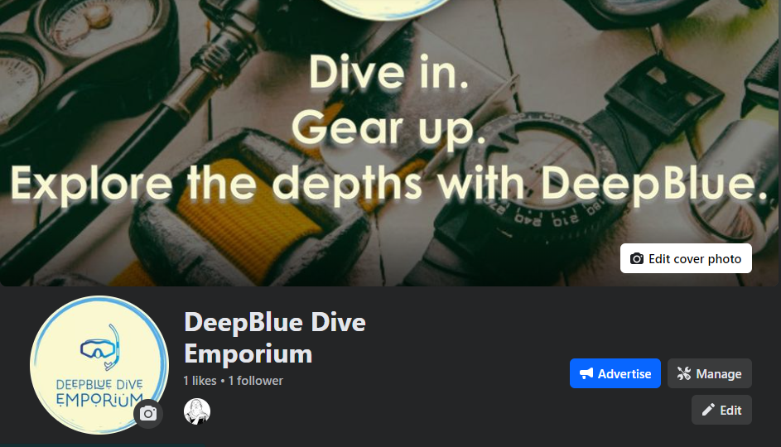

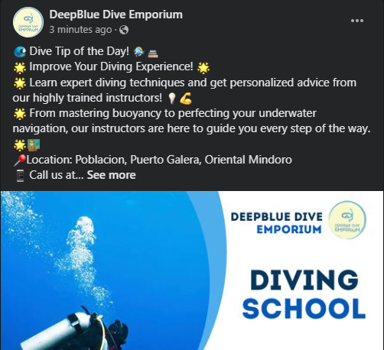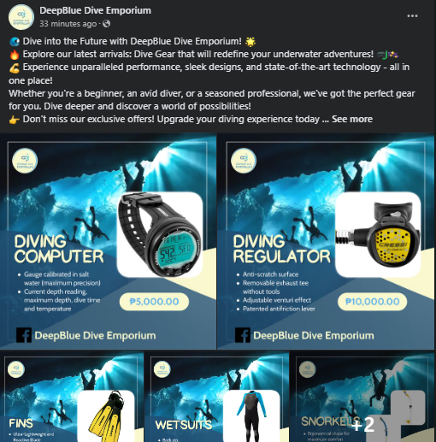

Our Facebook page consists of updated information about our business. We have a home page, we used an informative cover picture for the audiences to easily understand what is our page all about. We primarily offer our extensive selection of dive gear and accessories, including masks, snorkels, fins, wetsuits, regulators, dive computers, and more to make it east to find the perfect gear to enhance your underwater exploration. We also added our services which is mainly focused on giving personalized guidance and support from our knowledgeable staff every step of the way.

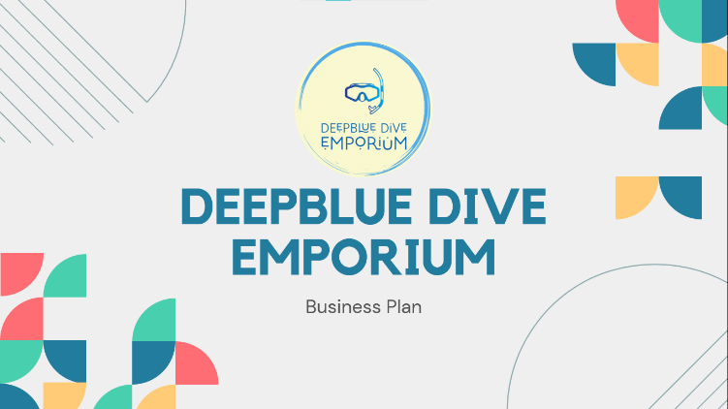APPENDIX B – POWERPOINT PRESENTATION

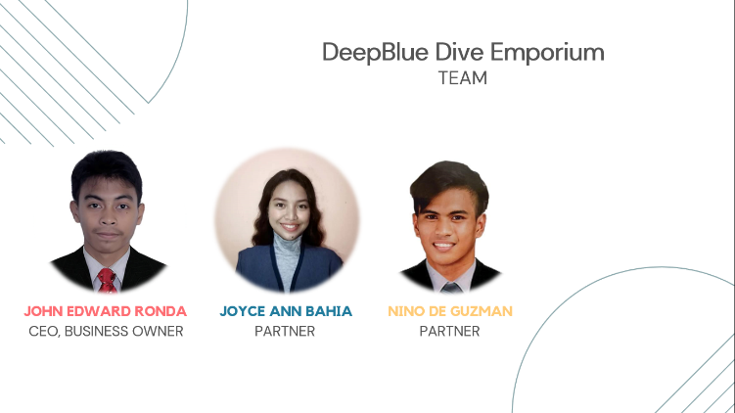

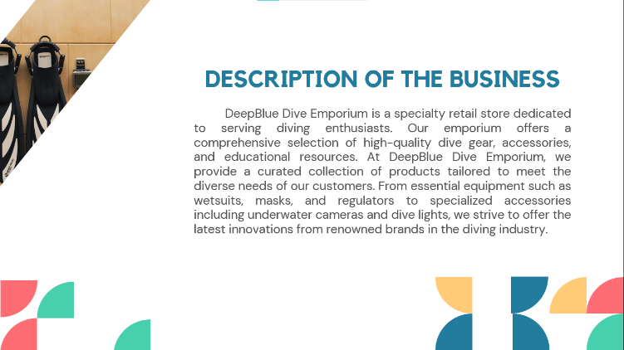

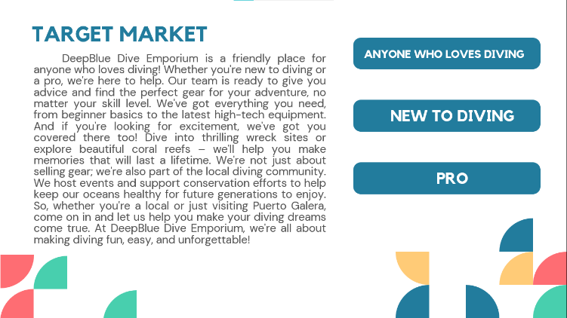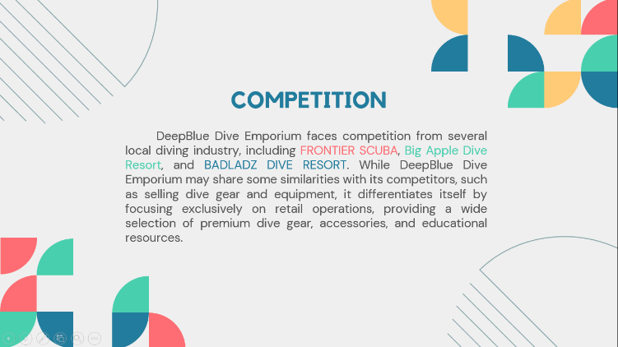

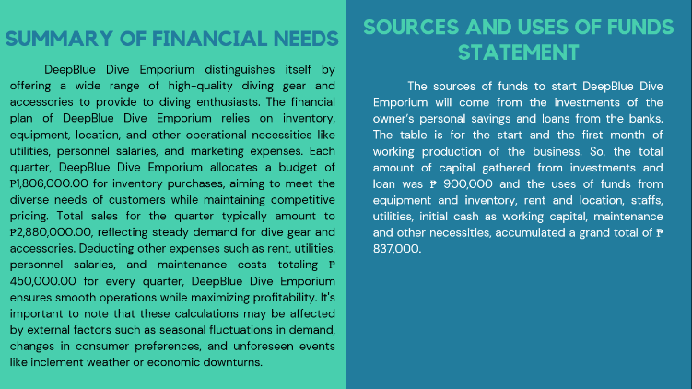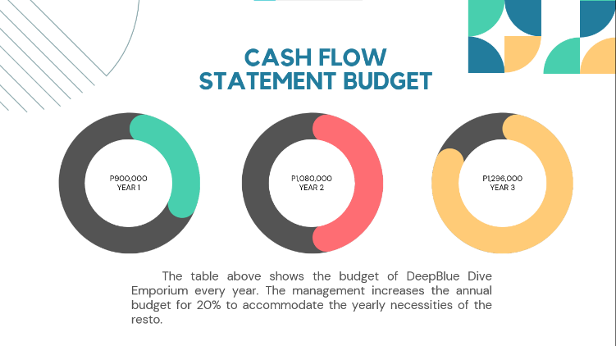



**APPENDIX C – CURRICULUM VITAE / RESUME**



**JOHN EDWARD B. RONDA**

Calangatan, San Teodoro, Oriental Mindoro

E-mail: [johnronda0527@gmail.com](mailto:johnronda0527@gmail.com)

Contact #: 09530356973

**PERSONAL INFORMATION:**

**Age:** 21

**Gender:** Male

**Birthdate:** May 27, 2002

**Birthplace:** Quezon City

**Name of Father:** Edward D. Ronda

**Name of Mother:** Rosario B. Ronda

**EDUCATIONAL BACKGROUND:**

***Elementary***

**School:** Paspasin Elementary School

**Address:** Paspasin, Calangatan, San Teodoro, Oriental Mindoro

***Junior High School***

**School:** Baco National High School

**Address:** Poblacion, Baco, Oriental Mindoro

***Senior High School***

**School:** Baco National High School

**Address:** Poblacion, Baco, Oriental Mindoro



**JOYCE ANN BAHIA**

Aurora, Naujan, Oriental Mindoro

E-mail: [joyceannebahia@gmail.com](mailto:joyceannebahia@gmail.com)

Contact #: 09108742667

**PERSONAL INFORMATION:**

**Age:** 21

**Gender:** Female

**Birthdate:** Jan. 29, 2003

**Birthplace:** Villa Celestial, Mansalay, Or Min

**Name of Father:** Jessie Bahia

**Name of Mother:** Myra Bahia

**EDUCATIONAL BACKGROUND:**

***Elementary***

**School:** Aurora Central School

**Address:** Aurora, Naujan, Oriental Mindoro

***Junior High School***

**School:** Aurora National High School

**Address:** Aurora, Naujan, Oriental Mindoro

***Senior High School***

**School:** Aurora National High School

**Address:** Aurora, Naujan, Oriental Mindoro



**NINO R. DE GUZMAN**

Panikian, Naujan, Oriental Mindoro

E-mail: [ninodeguzman149@gmail.com](mailto:ninodeguzman149@gmail.com)

Contact #: 09363755732

**PERSONAL INFORMATION:**

**Age:** 21

**Gender:** Male

**Birthdate:** March 07, 2003

**Birthplace:** Panikian, Naujan

**Name of Father:** Nestor de Guzman

**Name of Mother:** Lourdes de Guzman

**EDUCATIONAL BACKGROUND:**

***Elementary***

**School:** Panikian Elementary School

**Address:** Panikian, Naujan, Oriental Mindoro

***Junior High School***

**School:** Pedro V. Panaligan Memorial National High School

**Address:** Comunal, Calapan, Oriental Mindoro

***Senior High School***

**School:** Pedro V. Panaligan Memorial National High School

**Address:** Comunal, Calapan, Oriental Mindoro